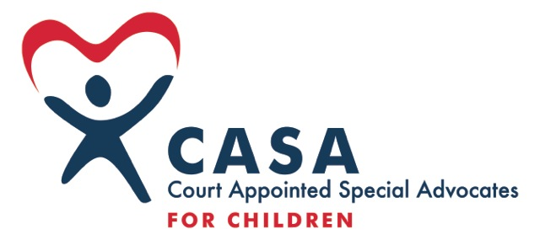 First Judicial District CASA Program
General Job Description and Position Responsibilities: Advocate Supervisor (part-time)- Shoshone & Benewah Counties
General Description:
The Advocate Supervisor is responsible for the supervision, case management, training, development, and coordination of assigned Advocates to ensure that abused and neglected children receive quality advocacy in court. This position reports to the CEO. The position is stationed in the CASA office in Kellogg, Idaho.
Position Responsibilities:
- ADVOCATE CASE MANAGEMENT
  - Supervise and assist with case management for up to 15 active Advocates and 3 Peer Coordinators on approx. 22 cases.
  - Maintain effective coordination with the court on case assignments, assign and reassign cases, notify Advocates of hearing dates, and submitting timely reports.
  - Provide quality case management and supervision of Advocates as required by state and national standards. Assure monthly contact with each Advocate and that each Advocate is visiting their child(ren) monthly.
  - Compile statistical case information as required by local, state, and National CASA/GAL programs and the CEO.
  - Review cases and reports and provide support and direction to assist Advocates with their independent judgment.
  - Collect and maintain data from Advocates regarding case updates. Organize and maintain case records (both hard file and on-line database), record and update case records in an accurate, regular and timely manner. Ensure data is entered in Optima for the previous month by the 10th.
  - Attend emergency hearings on a rotating basis. Attend as necessary. Serve on “call” rotation for vacations, sick leave, weekend shelters, etc.
- SUPERVISOR CASE MANAGEMENT
- Do not “staff manage” cases, except as approved in writing by the CEO.
- Motions to Withdraw must be approved in writing by the CEO.
- Perform same duties as listed above for Advocate-managed cases.
- ADVOCATE MANAGEMENT
- Continually evaluate each Advocate’s skills, strengths, and development needs concerning the cases assigned.
- Conduct Exit Interviews on each resigning Advocate with documentation in their personnel file.
  - Conduct an annual evaluation of each Advocate by June 30 of each year.
  - Provide recommendation on Advocate advancement and termination to the CEO.
  - Provide Advocates with report forms and resource information.
  - Confirm each Advocate is entering hours and mileage (thru Optima) by the 5th of every month for the previous month.
- RECRUITING/TRAINING
  - Assist Advocate Trainer with encouraging Advocates securing required 12-hour annual In-Service training.
  - Coordinate with the Training Specialist regarding training programs and in-service classes.
- OTHER
  - Hold office hours in Kellogg office and oversee administrative duties for Kellogg office.
  - Rely on appropriate administrative staff to perform additional administrative duties (ordering supplies, negotiating contracts with vendors, etc.)
  - Attend in-service and continuing education training as required by standards.
  - Assist Development Director with promotion Advocate recognition and appreciation events.
  - Participate in regular and on-going Optima training.
  - Participate as directed by the CEO in Supervisor and staff meetings.
  - Serve as part of the CASA team for office duties, fundraising events, Advocate events, personnel issues, etc.
Qualifications:
Bachelor’s degree in social services or related field, equivalent combination of education and experience, or experience as a CASA Advocate.
Proven ability to communicate, supervise and empower employees to be effective in their roles.
Proven ability to work cooperatively with various personalities and levels of experience and expertise.
Proven skills in Excel, Word, and Outlook.
Commitment to CASA’s goals and mission.
FLSA category, pay, and benefits:
Part-time, non-exempt position. 20 to 30 hours per week. $21,840 to $32,760 annually.
Pay is determined by experience and proven performance.
Benefits: see Employee Practices Handbook.

