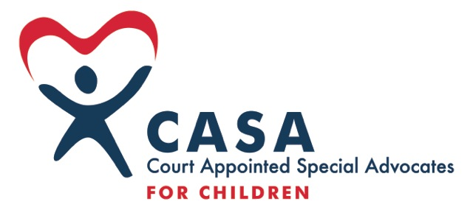 First Judicial District CASA Program, Inc.
General Job Description and Position Responsibilities: Assistant Advocate Trainer – 20-40 hours
Approved 11-10-21
General Description:
Assistant Advocate Trainer is responsible for training volunteer Advocates to ensure that abused and neglected children receive quality advocacy in court. The position will work to bring high quality training to the First District CASA on topics relevant to child protection. The position trains in Boundary, Bonner, Kootenai, Benewah and Shoshone counties. The position will require regular and frequent travel to these counties to teach the NCASA/First District curriculum; will require frequent professional development and travel to continuing educational training; and will include evenings and weekends. This position reports to and provides training and vacation/holiday support for the Advocate Recruitment and Training Specialist.
Position Responsibilities:
- RECRUITMENT
  - Work with Advocate Recruitment and Training Specialist and Development Director to identify recruitment strategies and assist meeting recruitment goals as identified in annual plans.
  - Perform public outreach to recruit, including preparing presentations and performing public speaking.
- TRAINING
  - Incorporate the requirements of NCASA, Idaho Statute, VOCA, and county- specific elements into the training curriculum.
  - Assist with preparation of the First District Training Schedule and ensure it incorporates a variety of days-per-week and times-per-day to maximize access to advocates.
  - Assist with monthly In-service training programs each year and maintaining record of Advocates attendance.
  - Perform reach of training opportunities, oversee registration, and document management.
  - Provide backup support for Pre-Service and In-Service training sessions during but not limited to, vacations, sick leave, unexpected schedule conflicts, etc.
  - Provide support for advocates struggling to acquire training hours.
  - Organize swearing-in ceremonies (invitations, food, group and personal oaths, picture IDs, etc.)
- RETENTION
- Provide Advocate’s with ongoing training of the Child Protection Act.
  - Work with Advocate Recruitment and Training Specialist to identify and attend Advocate recognition and appreciation opportunities.
- ADMINISTRATION
  - Participate in monthly staff meetings.
  - Meet reporting deadlines and compile statistical information as required by local, state and National CASA/GAL programs and the Advocate Recruitment and Training Specialist.
  - Assist with general administrative assistant duties as the time permits and needs arise.
  - Serve as part of the CASA team for office duties, fundraising events, volunteer events, personnel issues, etc.
u
Qualifications:
Bachelor’s degree in education, social service, marketing or equivalent combination of education and experience, or minimum of 1 year in facilitating adult training programs.
Commitment to completing Pre-Service training AND the required NCASA Facilitator training program.
Proven ability to communicate with and empower volunteers to be effective in their roles.
Proven ability to work cooperatively with various personalities and levels of experience and expertise.
Excellent communication and presentation skills and proven skills in customer service, public speaking, and interviewing.
Proven experience working with computer software including Microsoft Office, Outlook, Excel, Word, databases and working with audiovisual equipment.
Willingness to use personal vehicle for work travel and submitting mileage reimbursement requests.
Commitment to CASA’s goals and mission.
Preference given to:
Experience with volunteers and understanding of issues and dynamics within families in crisis relating to child abuse and neglect.
FLSA category, pay and benefits:
Options available: Non-Exempt position up to 29 hours, with likelihood of future expansion. Exempt position, 30-40 hours per week.
Pay $ per hour determined by experience and proven performance.
Benefits: see Employee Practices Handbook.

